**DAILY ONLINE ACTIVITIES SUMMARY**

|  |  |  |  |  |  |  |  |  |
| --- | --- | --- | --- | --- | --- | --- | --- | --- |
| **Date:** | **02/06/2020** | | | | | **Name:** | **PONICA.J** | |
| **Sem & Sec** | **4TH & B** | | | | | **USN:** | **4AL18CS055** | |
| **Online Test Summary** | | | | | | | | |
| **Subject** | | **-** | | | | | | |
| **Max. Marks** | | **-** | | **Score** | | | **-** | |
| **Certification Course Summary** | | | | | | | | |
| **Course** | **ROBOTIC PROCESS AUTOMATION** | | | | | | | |
| **Certificate Provider** | | | **GUVI(UIPATH)** | | **Duration** | | | **3 HOURS** |
| **Coding Challenges** | | | | | | | | |
| **Problem Statement:** Given an array arr[] of integers and an integer K, the task is to print all subsets of the given array with the sum equal to the given target K. | | | | | | | | |
| **Status:EXECUTED** | | | | | | | | |
| **Uploaded the report in Github** | | | | | **YES** | | | |
| **If yes Repository name** | | | | | **https://github.com/ponica-jaya/LOCKDOWN-CODING.git** | | | |
| **Uploaded the report in slack** | | | | | **YES** | | | |

Online Test Details: (Attach the snapshot and briefly write the report for the same)

TODAY NO TEST WAS CONDUCTED

Certification Course Details: (Attach the snapshot and briefly write the report for the sa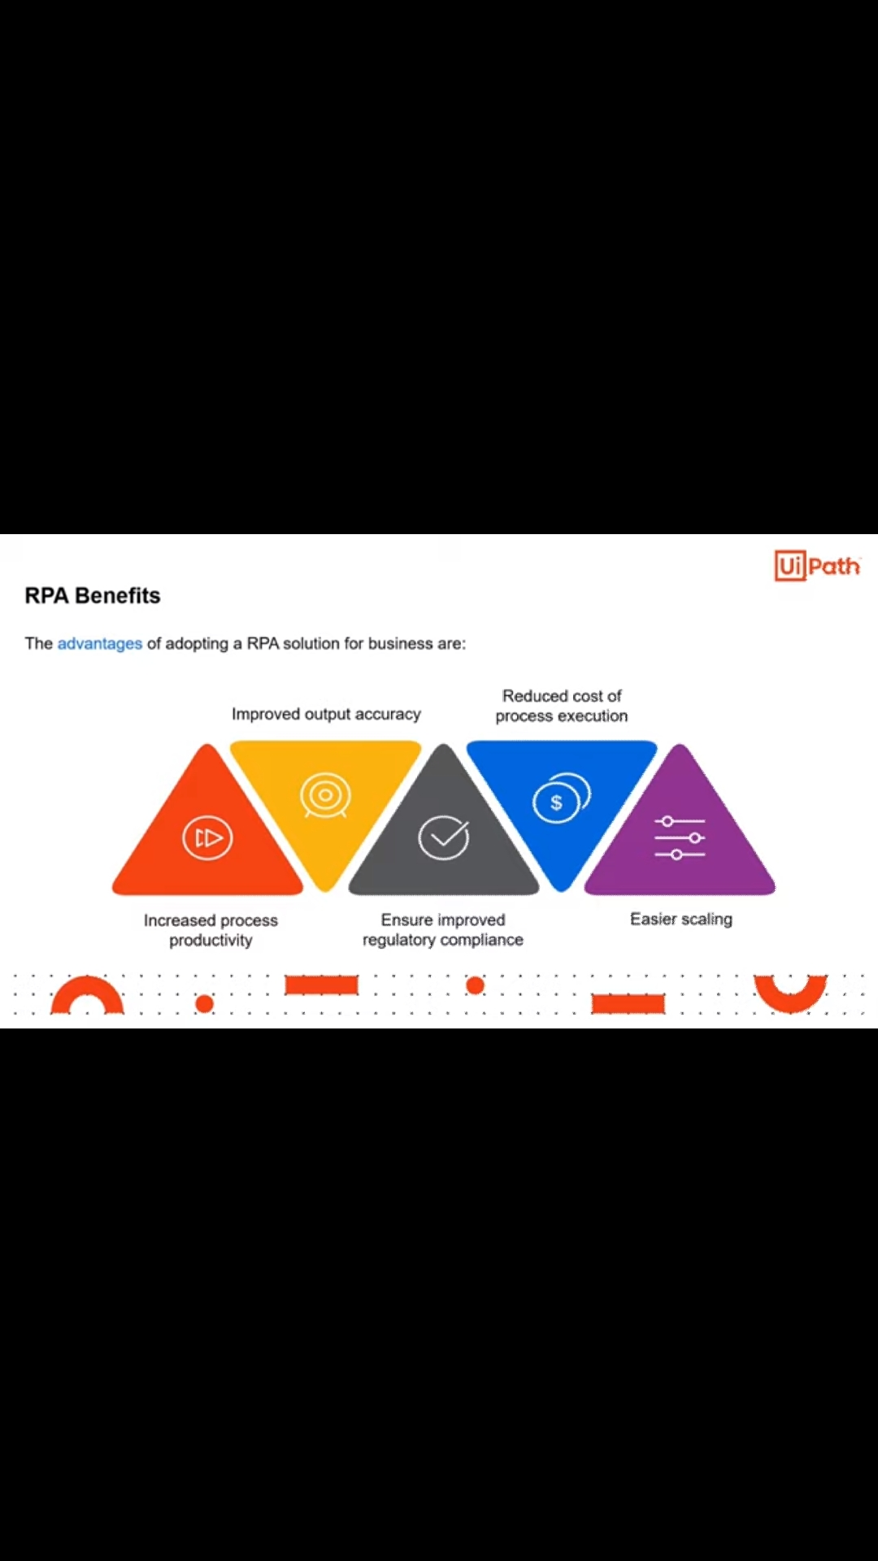me)

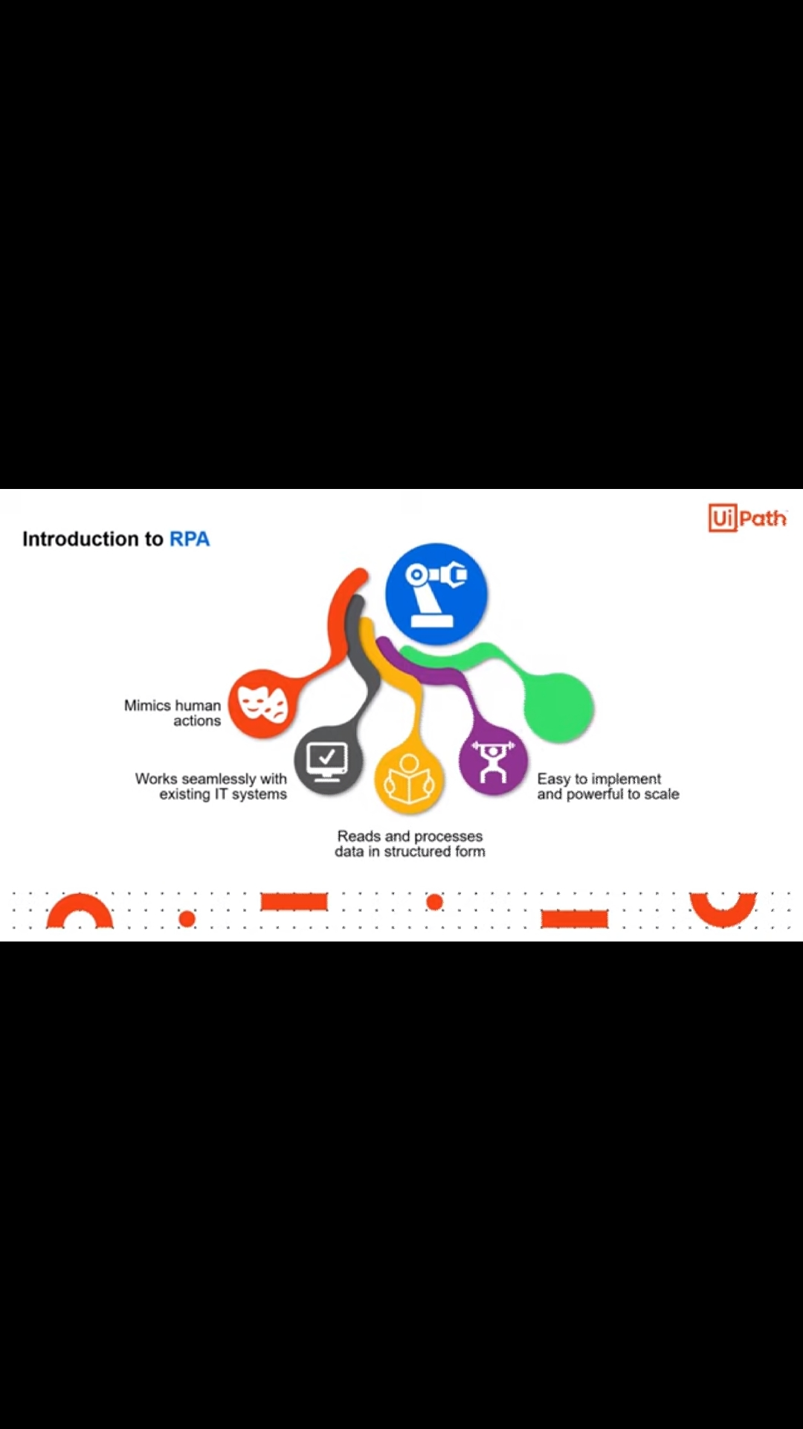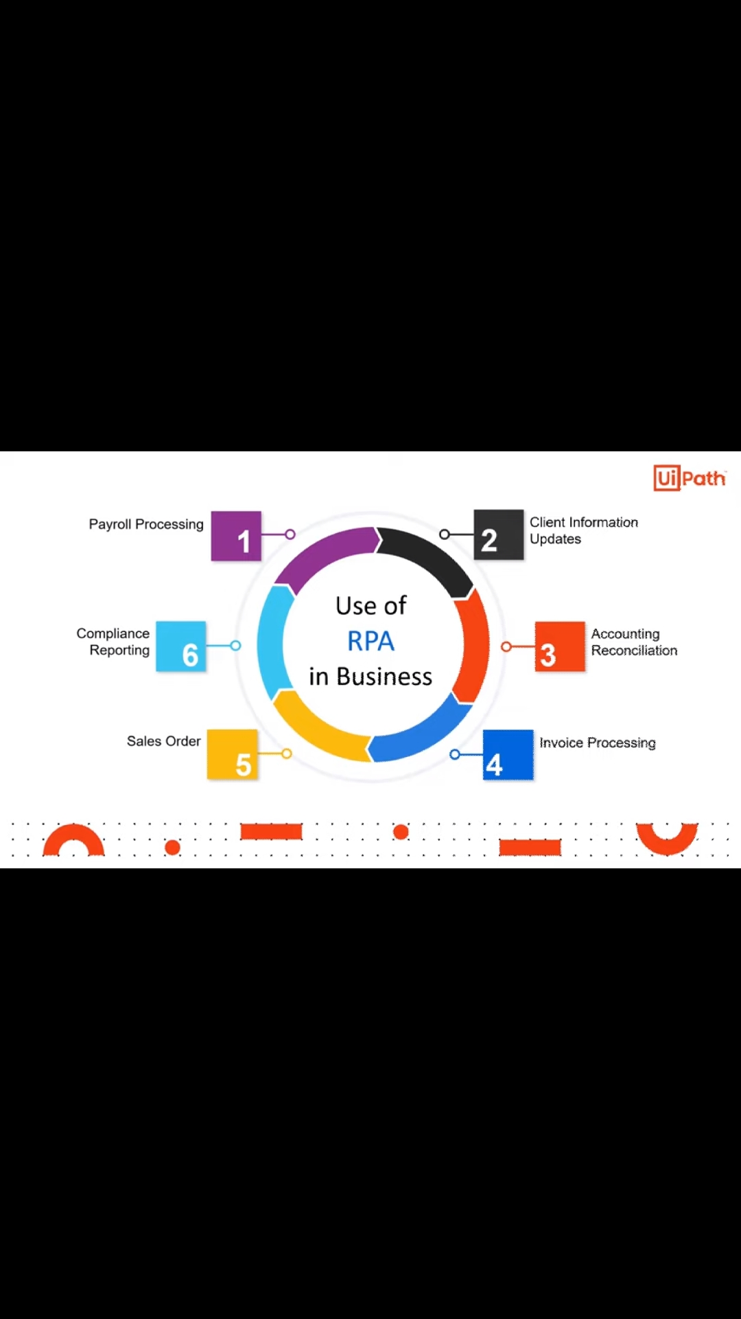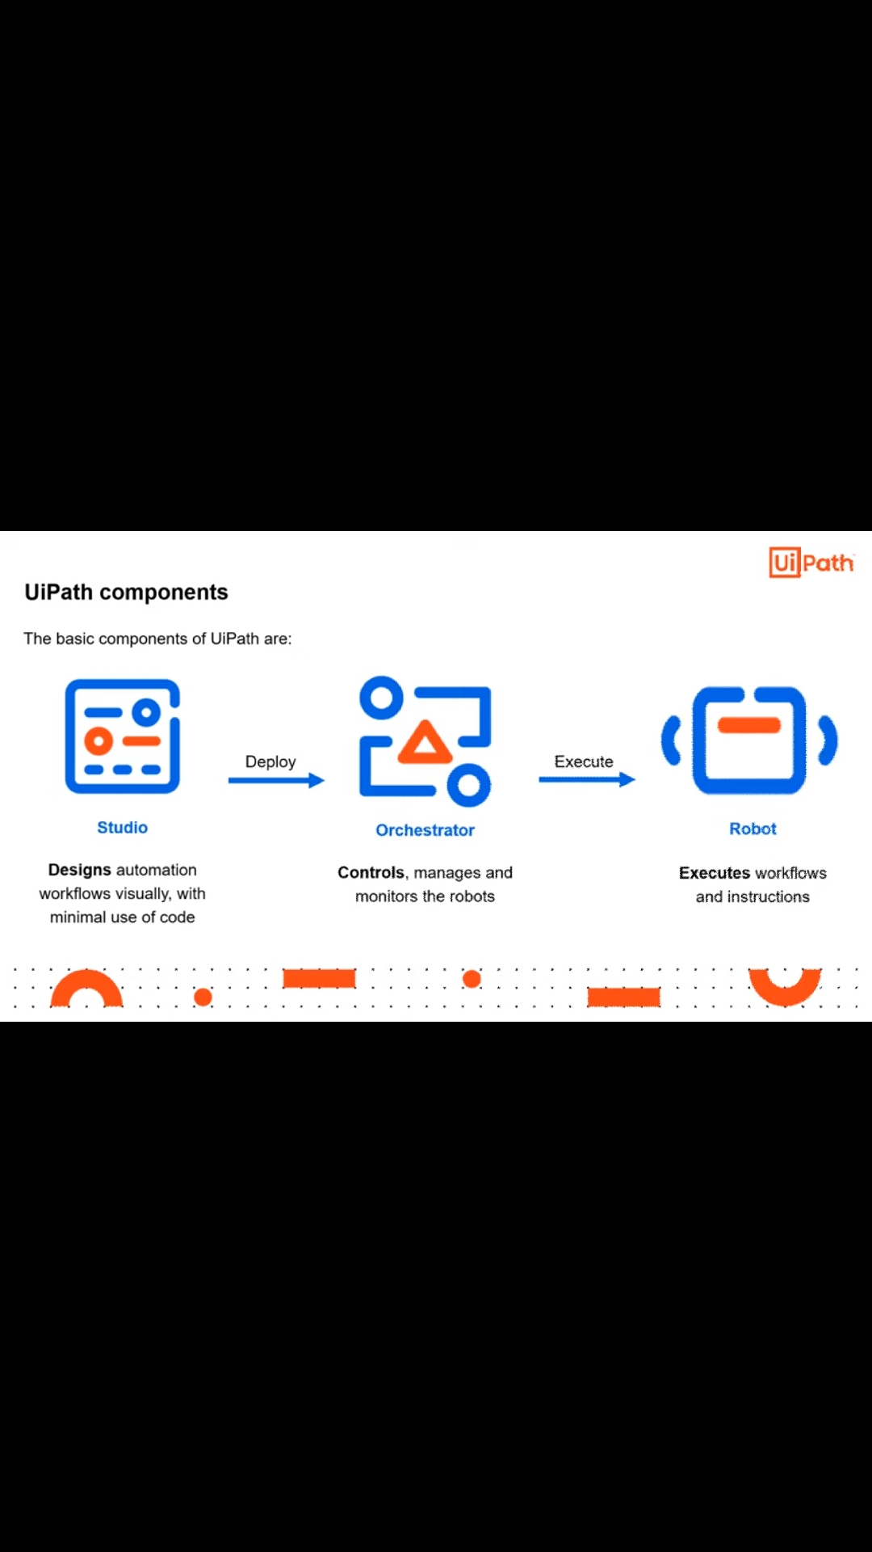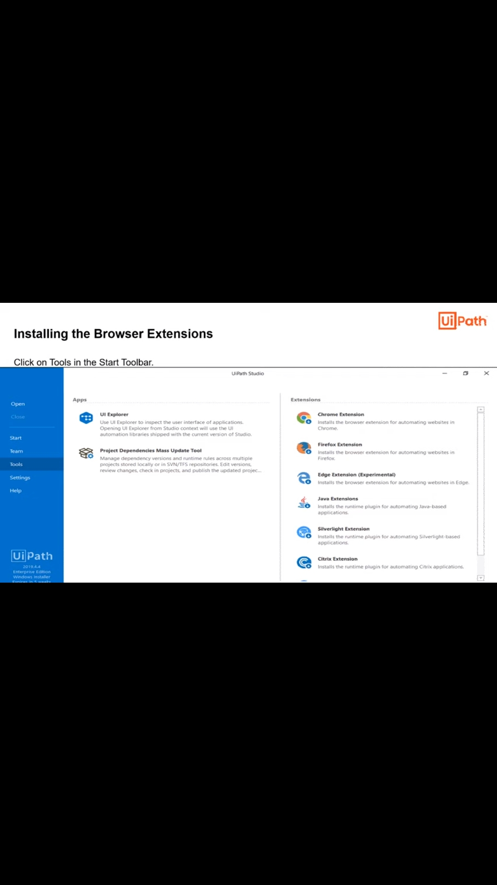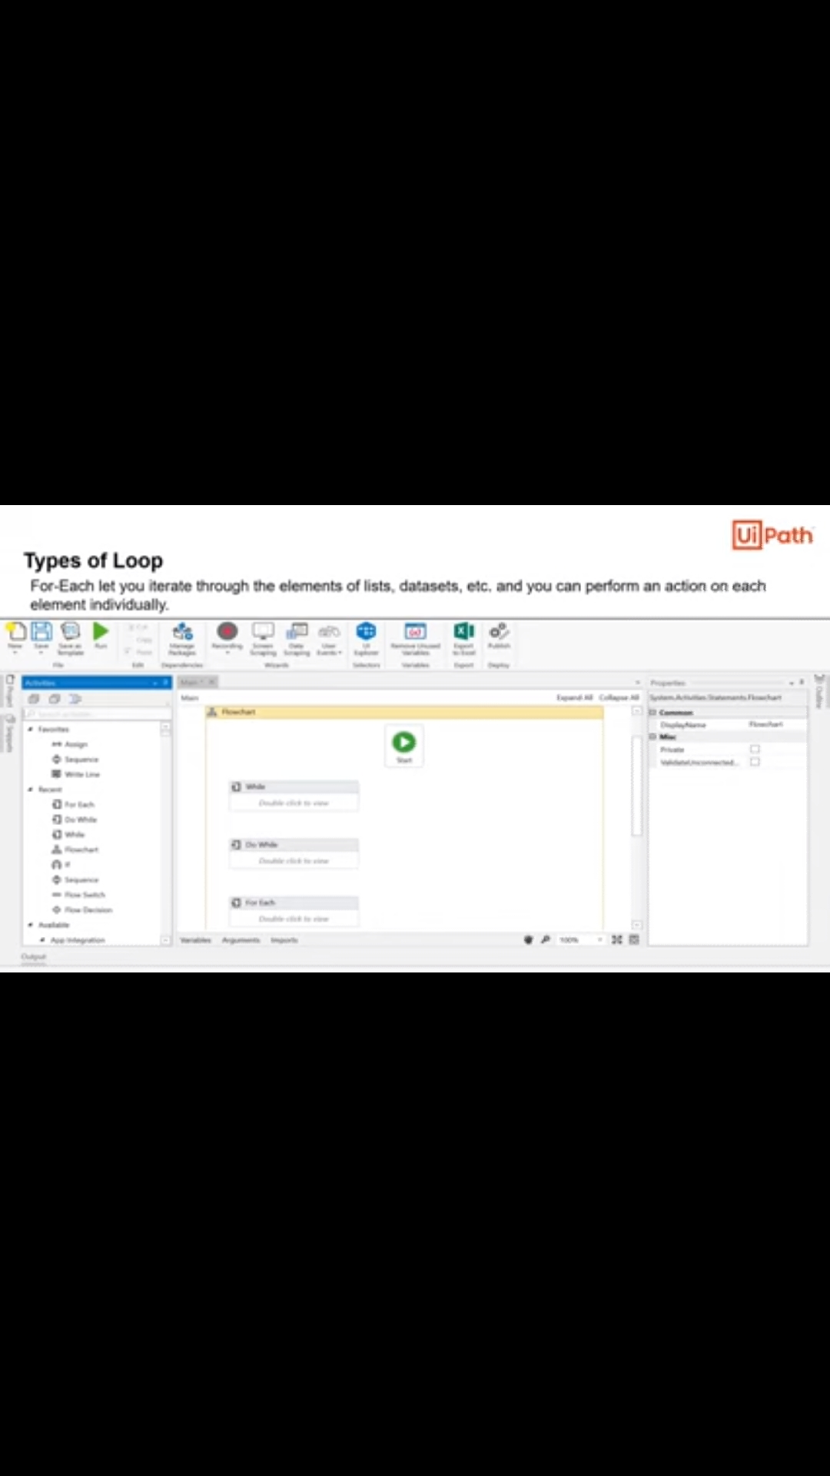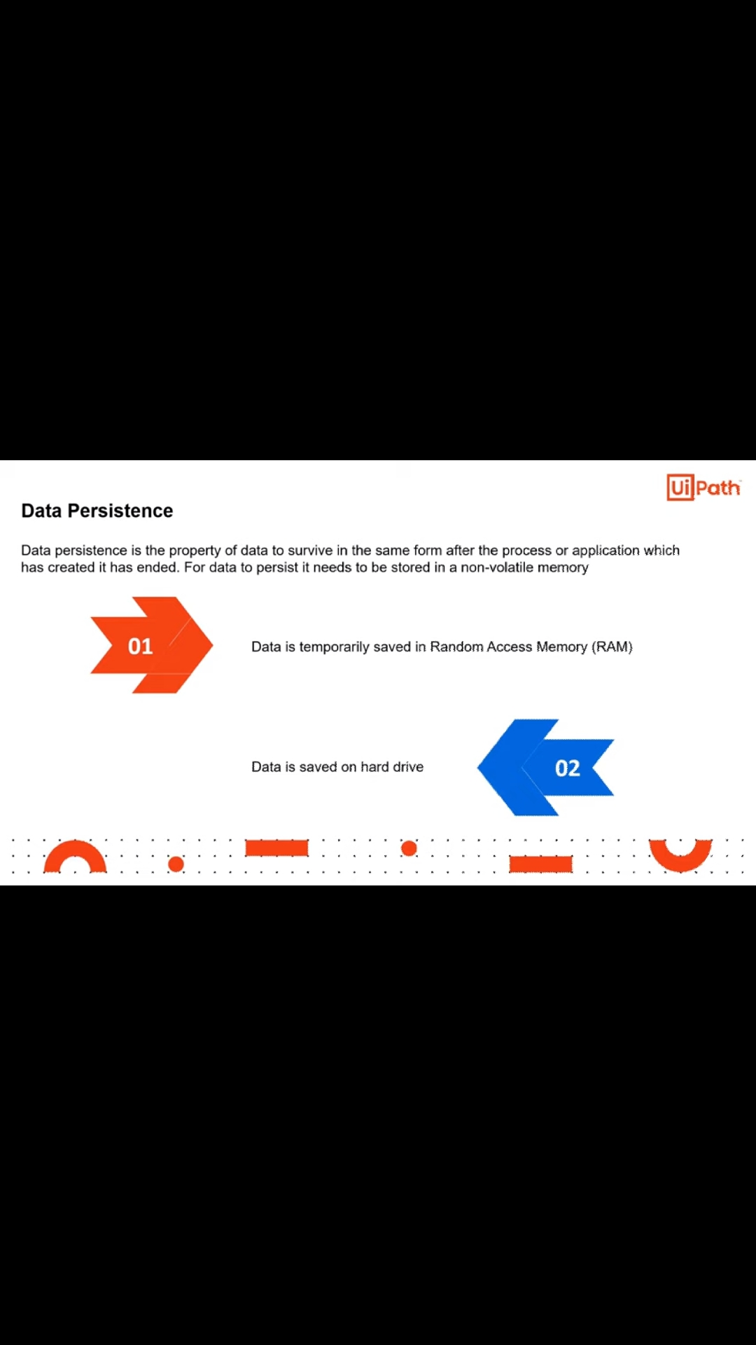

Coding Challenges Details: (Attach the snapshot and briefly write the report for the same)

Given an array arr[] of integers and an integer K, the task is to print all subsets of the given array with the sum equal to the given target K.

**Examples:**

**Input:** arr[] = {5, 10, 12, 13, 15, 18}, K = 30  
**Output:** {12, 18}, {5, 12, 13}, {5, 10, 15}  
**Explanation:**  
Subsets with sum 30 are:  
12 + 18 = 30  
5 + 12 + 13 = 30  
5 + 10 + 15 = 30

Input: arr[] = {1, 2, 3, 4}, K = 5  
Output: {2, 3}, {1, 4}

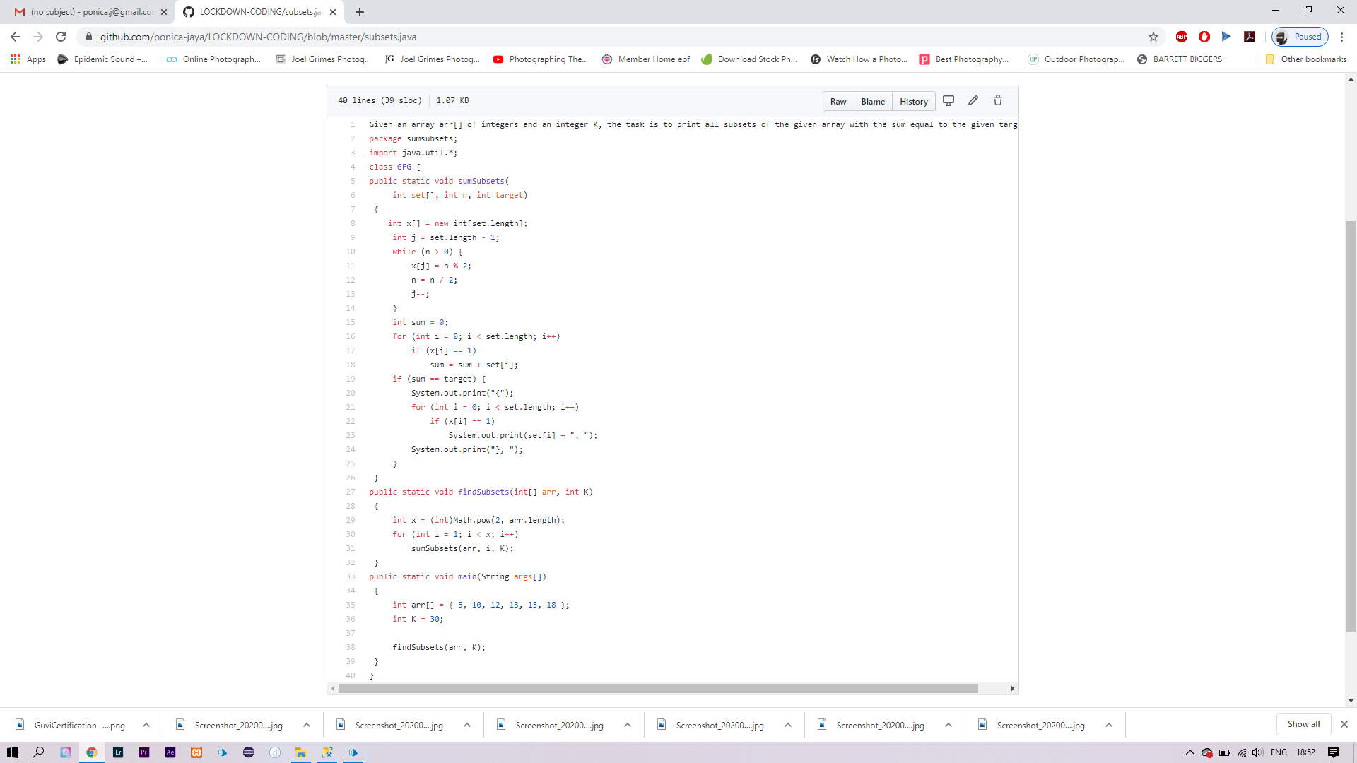

SOLUTION: I HAVE SOLVED THE PROBLEM GIVEN BY MY TEACHERS AND THEN UPLOADED IN MY GITHUB ACCOUNT.

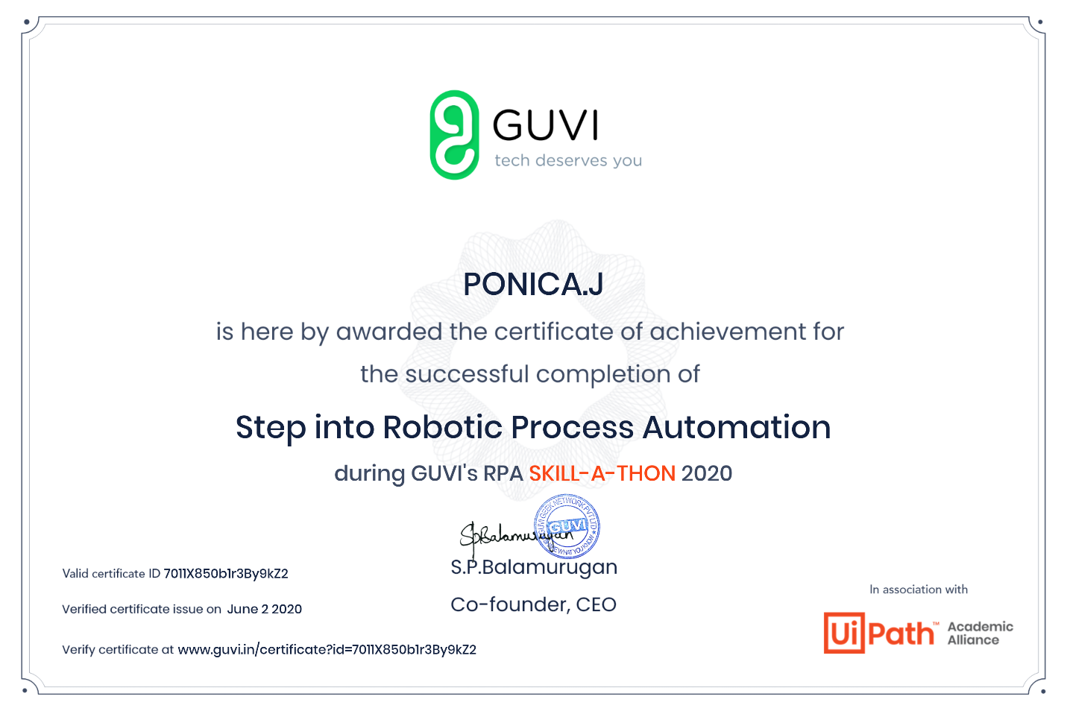

THIS IS MY CERTIFICATE OF TODAY’S COURSE